Derek Leung

1. -
   1. 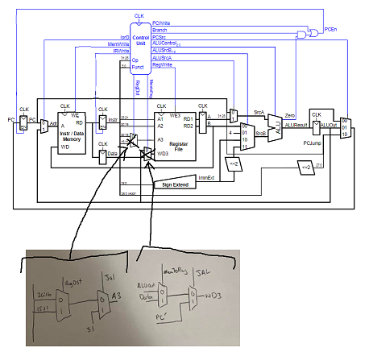
   2. 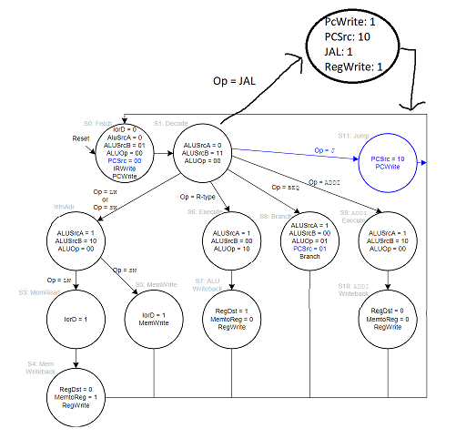
2. -
   1. The cycle time for a multicycle processor is 15ns (longest cycle time)
   2. 15 \* 5 = 75ns (Cycle time is 15ns and lw has 5 cycles)
   3. 15 + 6 + 3 + 15 + 6 = 45ns
   4. Average CPI = (.08)(5) + (.37 +.04)(4) + (.33 + .18)(3) = 3.57

(#instructions)×CPI×Tc

Multicycle: 100 \* 3.57 \* 15 = 5355 ns

Single Cycle: 100 \* 1 \* 45 = 4500 ns